DEVOPS TASK – 3

1. Installation of kubectl :

**COMMAND:**

curl -LO "https://dl.k8s.io/release/$(curl -L –s

[https://dl.k8s.io/release/stable.txt)/bin/linux/amd64/kubectl"](https://dl.k8s.io/release/stable.txt)/bin/linux/amd64/kubectl) sudo install -o root -g root -m 0755 kubectl /usr/local/bin/kubectl kubectl version --client

**SCREENSHOT :**



1. Installation of Minikube:

**COMMAND:**

sudo apt install -y curl apt-transport-https conntrack curl -LO https://storage.googleapis.com/minikube/releases/latest/minikube-linux-amd64 sudo install minikube-linux-amd64 /usr/local/bin/minikube minikube start --driver=docker minikube status

**SCREENSHOT :**

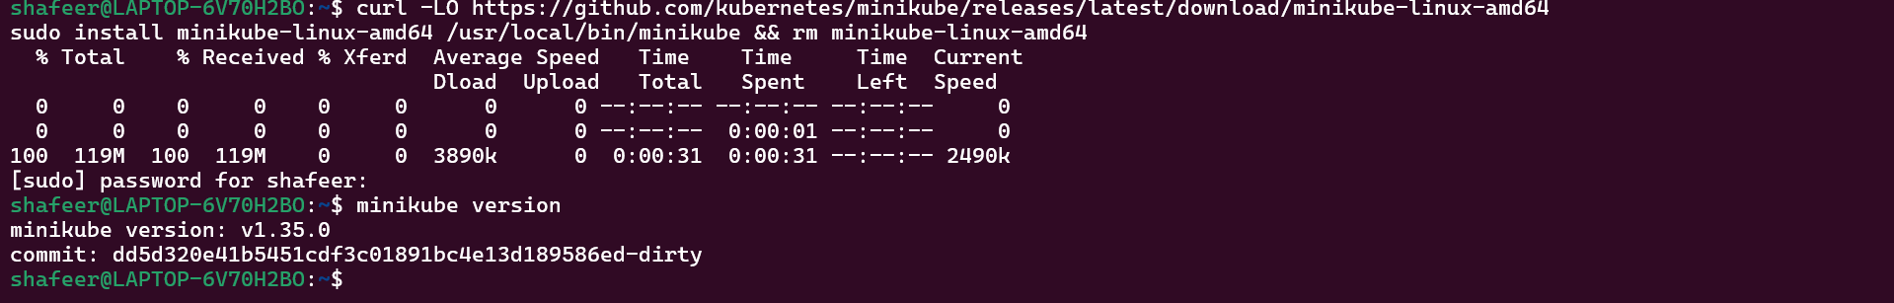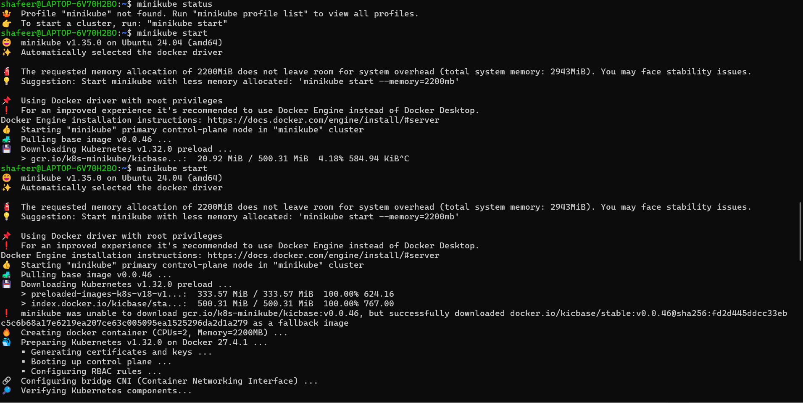

1. Create a deployment for the docker hub image using this command and get the pods.

**COMMAND:**

kubectl create deployment r1 --image=shafeer2511/test --port=80 kubectl get pods

**SCREENSHOT :**

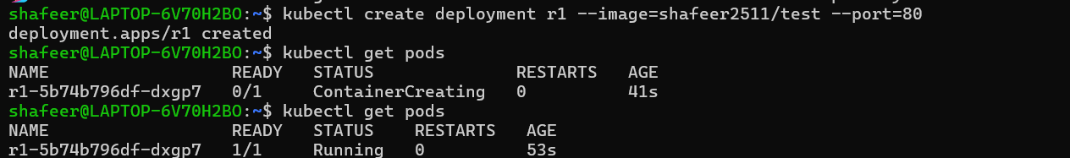

1. Then expose the deployment in that same port and run the service using minikube.

**COMMAND:**

kubectl expose deployment r1 --port=80 --type=NodePort

minikube service r1

**SCREENSHOT:**

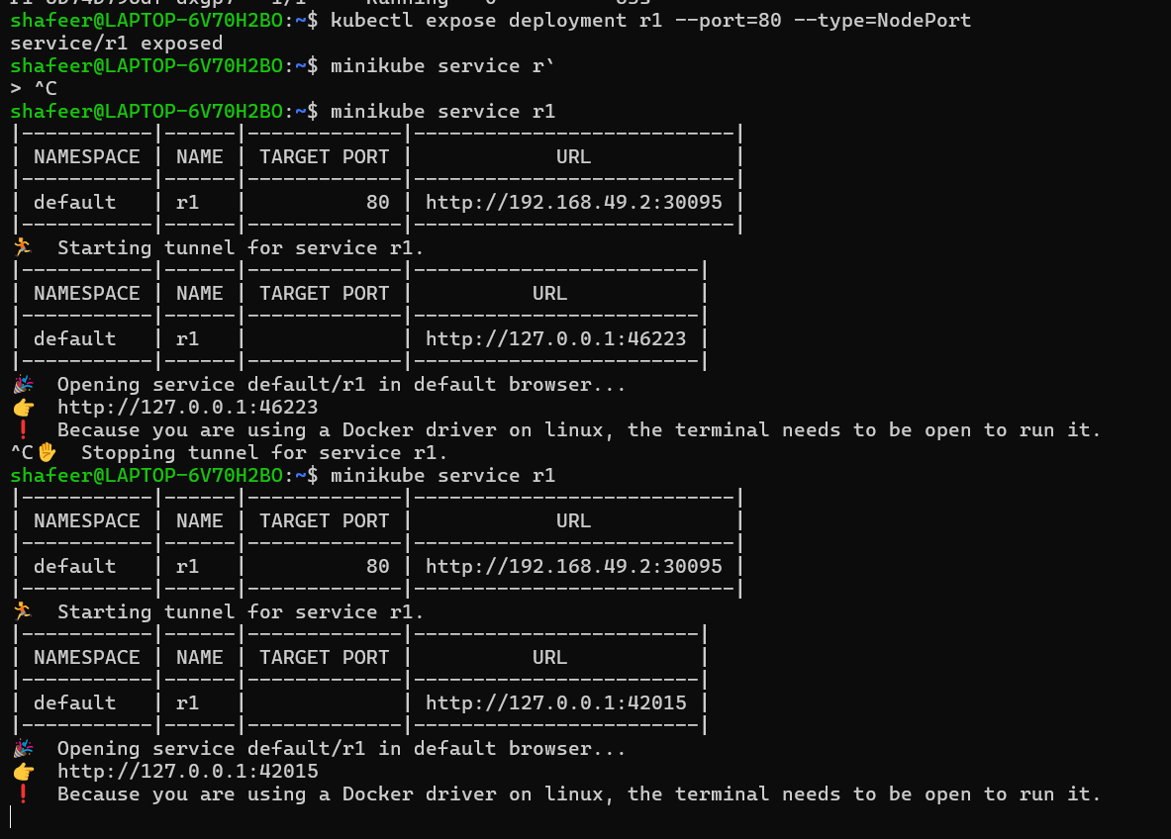

1. Now our image will be hosted locally on the given url . Go to the browser and search for it.

**SCREENSHOT :**

